Activity: Discovering the Purpose: Logging In to ONE Access

Purpose: Designed to be used as a tool in an introductory lesson when teaching students to navigate and log into ONE Access, these activities may be used to gain knowledge of the resources, their purpose, and to use them in short, critical thinking activities with students.

Submitted by: Kim Ray, District Media Specialist

Overview: While teaching students to log into ONE Access, it is essential to support them in engaging with a variety of resources, such as eBook platforms and databases. The following resources have been created to help students gain an understanding of the purpose of a variety of resources, to navigate several resources of choice, and to use information from the resources they explore (apply) in critical thinking activities. After exploring resources, students might be grouped to share what they learned about the purpose and features of the resource(s) they explored with those who chose different resources. It is strongly suggested that these activities are modified to fit the specific needs of students in your school community through collaboration with content area teachers and are only used when teaching students an overview/navigation of ONE Access resources. Future lessons should be structured to promote inquiry learning, research skills, and reading comprehension, and be rigorous and standards-aligned in design.

See Challenge Below

ONE Access Resource Challenge
Complete at least 3 tic-tac-toe squares

Weddings: Near & Far  Using the CultureGrams resource, watch a Cameroon wedding procession.  How is it different from a traditional American wedding? How is is the same? What features would you want to include if you planned a wedding? | E-book 3-2-1 List  Make a list from the NC Kids Digital Library of:  3 fiction books you want to read that share a theme (i.e. friendship, sports, etc)  2 nonfiction books with subjects you want to read about  1 resource (not a book) | Solar Poetry  Read about a Space topic in PowerKnowledge Earth & Space Science.  Create an acrostic poem using the topic as your word. Share 5 or more things you learned by reading about this topic.
TumbleBooks Play List  Explore the resources on Tumble Books.  Using the Play List feature (in the blue bar), create a My Play List of things you found on Tumble Books that share a theme. Give it a name and share it. | 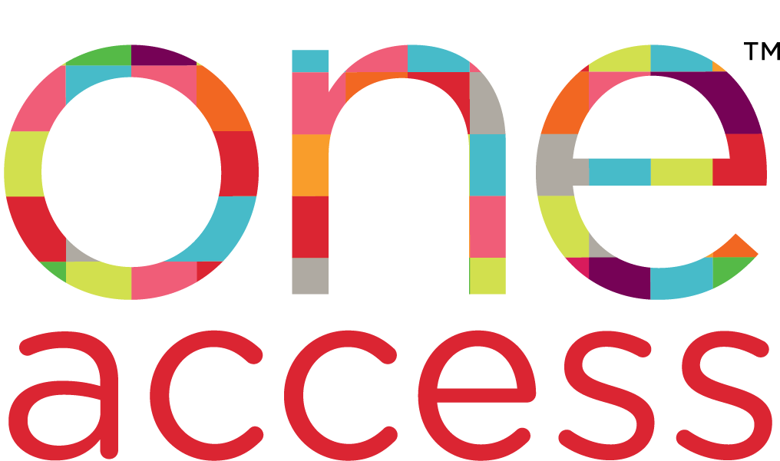  Username:  CMS Student ID number  Password:  Last 4 digits of ID number | Interview Fun  Using World Book Encyclopedia Online, research a famous person.  Based on what you read, write 10 interview questions to learn more about about the person you chose.
Current Event Cartoon  Using the SIRS Discoverer resource, read about a Current Event.  Write/draw a cartoon to show a perspective (or two) about the current event. | Best State Ever Award  Use the NCPedia resource to learn about different aspects North Carolina.  Write/illustrate 5-10 reasons why North Carolina should be considered the “Best State Ever”. | Dream Pet  Use a resource of your choice (like World Book Encyclopedia or PebbleGo Science) to learn about an animal of your choice.  Write a letter to your parents with three reasons why this animal is your dream pet.

